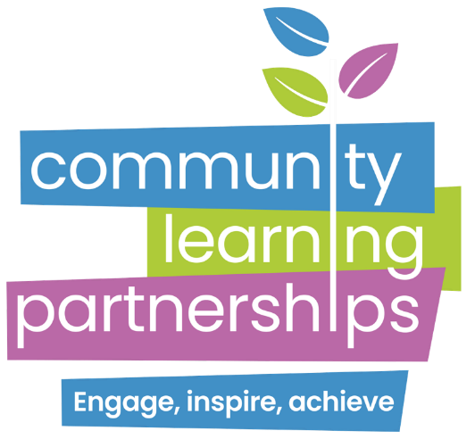

PRIVACY POLICY

Your rights relating to use of your personal data changed in May 2018, with the 'General Data Protection Regulation' or GDPR, and the Data Protection Act 2018, coming into force.

This Privacy Policy explains how Community Learning Partnerships processes your personal data under these new laws.

If you have a query about this Privacy Statement please contact us.

How we use your personal data
Community Learning Partnerships collects personal data about you to fulfil our legal and funding obligations. What information we collect about you depends on which of Community Learning Partnerships’ services you might use, and how much personal data about you is needed to provide you with access to our services. These are explained below.

Course Enquiry/Referral
If you call to enquire about our courses or wish to enrol on a course, the contact details given during this conversation will be recorded and retained by us for a maximum of six months. If after this time you have not used the services of Learning Partnerships then your details will be deleted.

Programme Support/Services
If you are referred to us and booked directly onto a course at Community Learning Partnerships, we will collect and use personal data to provide this service to you.

Specific personal data is required to be obtained and we will collect your name, address, telephone number and e-mail address and also ask for specific course relevant eligibility criteria, where this applies. You may also indicate any special support needs you may have.

Community Learning Partnerships may use the personal data collected for the provision of courses to contact you in regards to other suitable training opportunities or referrals and also to carry out evaluation of our services to ensure that our clients’ needs are met and to also inform you of any changes to our programmes.

We may share personal data to be used by other organisations that may provide you with support. Where this happens, we will ensure that you have given permission for this data to be shared and that the use of this data complies with the law and is kept secure at all times.

Use of personal data for internal Community Learning Partnerships’ research
We may use personal data collected as part of the services we offer to also conduct research into local trends/needs and on the performance of Community Learning Partnerships in meeting users’ needs. We may also use some of the data when applying for funding applications. However no specific personal data will be shared unless permission has been sought.
Where we do use personal data for research purposes, as far as possible we will try to make this unidentifiable before we use it. This is to help ensure that your privacy is respected when personal data is used by Community Learning Partnerships’ staff for funding and research purposes, or by those providing research services to us.

Making a Freedom of Information (FOI) or Subject Access Request (SAR)
If you wish to make an FOI or SAR, your contact details and case history will be collected to process your request and will be kept for two years.

If you wish to make a complaint to the Information Commissioner's Office (ICO) regarding a decision on a FOI or SAR, Community Learning Partnerships is legally obliged to share any personal data or records we hold, which includes personal data, with the ICO in order to progress your complaint. You may withdraw your complaint at any time.

Sensitive Personal Information
Some of the information you provide to us may be sensitive personal data, such as medical history, criminal convictions, or racial/ethnic origin.

We will only ever use sensitive personal data where this is essential to provide a service or access to our programmes. We may also use medical information you provide to make reasonable adjustments to help you access our services and to ensure the safety of our staff.

Confidentiality, storage and security of personal data
Community Learning Partnerships views the confidentiality and privacy of those using its services as paramount. Any personal information you provide will be held securely, and your personal information will not be sold or traded to another organisation or company.

In order to carry out our functions and respond to enquiries effectively, we may sometimes need to share information with Government Departments, funding bodies and referral agencies. However, we will only do this where prior permission has been sought or where it is permitted by law.

Where Community Learning Partnerships might share personal data with an external organisation or service that we work with to ensure that the needs of our service users are met, we will ensure that personal data that we may pass on to them will be held securely, and used by them only to provide the services or information that you have requested.

Community Learning Partnerships safeguards the information you provide to us using physical, electronic and management procedures on use of personal data. We use password protection on electronic records and all paper based personal data is held securely in locked filing cabinets, with restricted access as required.

Your rights under data protection law
You have a right to request a copy of the information that Learning Partnerships holds about you. You have the right to have any inaccuracies corrected.

You may also have the right to have your personal information erased; to restrict our use of your personal data; to object to our processing of your personal data; and to obtain and reuse your personal data for your own purposes across different services ('data portability').

You have the right to complain to the national authority on the use of information, which in the UK is the Information Commissioner's Office
Please address requests (with a return e-mail address where possible) to:
Debbie Blackburn
Chief Executive Officer
Community Learning Partnerships
Shine
Harehills Road
Leeds LS8 5HS
Telephone: 0113 3806662
Email: info@learningpartnerships.org.uk

Use of our website and Social Networking
When you visit our website, we collect via Google Analytic the following:

- data about how you use the Community Learning Partnerships’ Website
- device information (including browser type)
- demographic data
- gender, age, language, hobbies and interests

This information is obtained via cookies and advertising. As a user you have the choice whether to accept cookies or not. Cookies are small pieces of data sent to your computer when you visit websites and collect information about you. They are stored in the cookie directory of your hard- drive, and do not necessarily expire at the end of your session. Session cookies are automatically deleted when you close your browser.

Our social media sites offer you the opportunity to 'like' or 'share' information about Community Learning Partnerships.

Sharing your personal data with a social media network may result in that information being collected by the social network provider or result in that information being made publicly available.

Community Learning Partnerships cannot control or endorse any policies or practices of external social media networks whose functionality you may access. You should always read the privacy policy, and check your privacy settings, on any social media network through which you might share information.

Community Learning Partnerships’ website may contain links to other websites and services. These websites are not covered by this Privacy Statement and Community Learning Partnerships is not responsible for the privacy practices within any of these other websites. You should be aware of this when you leave the website and we encourage you to read the privacy statements of other websites.

Changes to this Privacy statement
If this privacy statement changes in any way, we will place an updated version on the webpage. If you do not agree with the changes we make, please do not continue to use the website. Regularly reviewing the webpage ensures you are always aware of what information we collect, how we use it and under what circumstances, if any, we will share it with other parties.

Created by: Lisa Metcalf, Senior Executive – HR & Business Resource | Date: 18th May 2018
Reviewed by: Jon Hosegood | Date: 25 October 2024
Amended by: | Date:
Approved by: Executive Team | Date: 25th May 2018
Version: 1

